Session 27

|  |
| --- |
| **Objectives**  The goals of this session |
| 1. Finishing Terrain & Colour on Focus Activity |

|  |
| --- |
| **Method Focuses**  New methods or functions that you will learn during this session |
| **Casting**  int a: float value = (float) a; |
| **Property Focuses**  Properties (variables) of classes you will learn during this session |
| No new properties |
| **Documentation Links** |
| **N/A** |

## Focus Activity 2

Based on Focus Activity 1.

Prompt: Create a basic forest that has trees in certain areas and has a basic cubic terrain with varying heights using Perlin noise.

Requirements:

1. Terrain created based on Perlin Noise
2. Trees are placed based on Perlin Noise and elevation (must be on grass)
3. Low elevation is blue, slightly higher is yellow and above is green as shown below.
4. Variable size

|  |
| --- |
| Grass (green) |
| Sand (yellow) |
| Water (blue) |

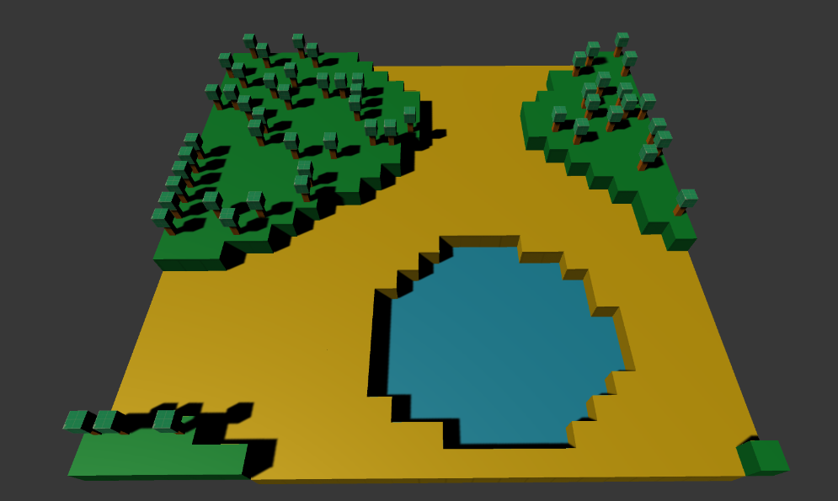

*Note in the image above the noise value of the tree was adjusted to make it more random by using the formula:

PerlinNoise *= Random.Range(0,5)

|  |  |
| --- | --- |
| **Session Information**  You can ignore this | |
| **Planned Information** | |
| Session Time Session Date | 5:00PM – 6:00PM AWST 13 April 2021 |
| **Real Information** | |
| Session Time Session Date | 11:00AM – 12:00PM AWST 14 April 2021 |
| Github Name | Session27Examples |
| Session Length | 1 hour |
| Activities Completed | |  |  | | --- | --- | | □ | Focus Activity 2 Continued | | □ | Terrain Completed | | □ | Terrain Colour Completed | | □ | Perlin Noise Understood | |
| Signature | ____________________________________________  *By signing this you confirm that the session has occurred and the subjects that have been taught have been allocated on this document.* |